**Heuristic Review of the “inflo” Web Application**

**Summary**

The Second Mockathon UX team was tasked to perform an evaluation of the “inflo” website on 21 March 2015. This report summarizes the high level findings of this evaluation.

Two primary concerns were exposed. Complicated language was used throughout the application that would confuse the user and discourage use. A lack of simplified instruction was not available creating a unclear landing page. Detailed descriptions of all usability issues exposed during this evaluation are included in the following sections.

**Assessment Method**

Heuristic evaluation is an assessment method which rates software applications and interfaces based on compliance with basic human factors principles of design. For this evaluation, four areas were considered.

1. Perceiving and Evaluating the System
2. Developing and Executing Action Sequences
3. Context and Relations
4. Specific Interface and System Issues

**Overall Impressions**

From the inflo homepage, users can easily search for a county to view comparative data from. However no information on what data will be retrieved is available. There is no example data available and no description of the pages purpose. The page focus should be set on the input box on page load.

The inflo dashboard shows the county and associated state that was searched for. It gives an overall score that is not self-explanatory. The score percentage should be in comparison to all other counties to show context. Four tiles showing Water Quality, Air Quality, People, and Travel Safety are showing county data. This data does not provide context and displays a percentage that is not associated with a positive or negative result. Results should show percentages lower or higher than all counties data.

**inflo Home Screen (Wireframe):**

* Logo centered at top (alt text for logo image)
* Search centered under logo (alt text for search button if image used)
* Search includes example input “Fairfax, VA”
* Focus is on search on page load
* Tagline below search box
  + “How much do you know about where you live?”
* Search informative infographic
  + “Search for Your County” “View the Score” “Explore the Details”
  + Three screenshots showing steps. (alt text explaining images)
  + Arrows showing flow. (alt text “Arrow pointing right”)

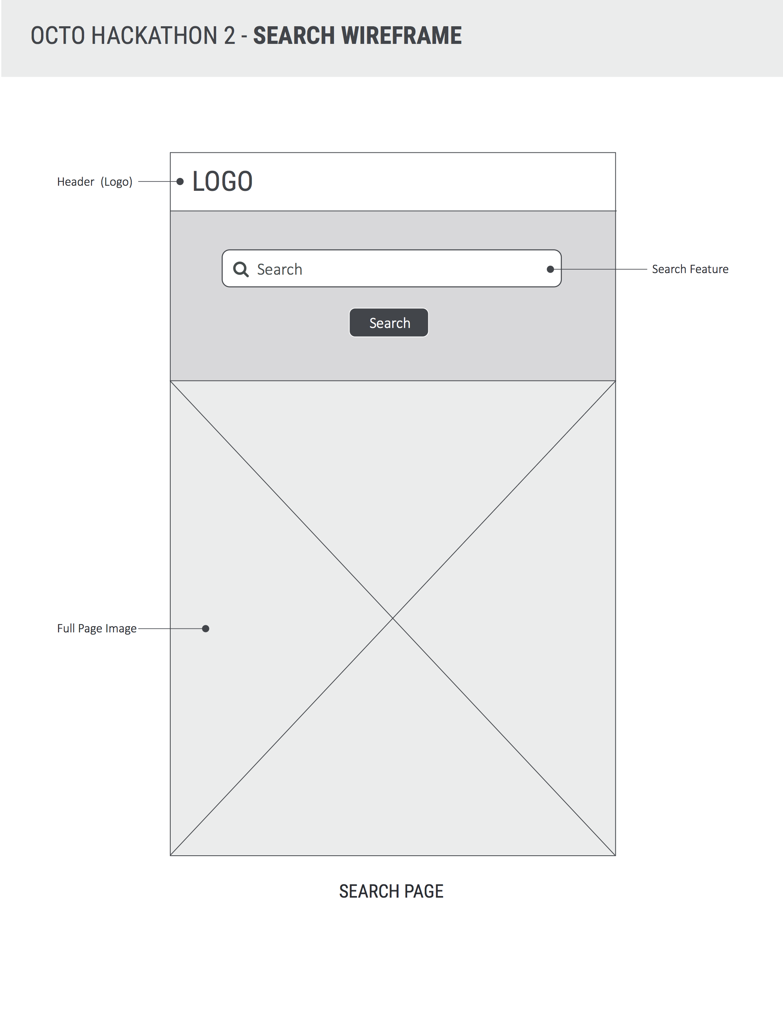

**inflo Dashboard Screen (Wireframe):**

* Logo centered at top (alt text for logo image)
* Search centered under logo (alt text for search button if image used)
* Search includes example input “Fairfax, VA”
* Focus is on search on page load
* Tagline below search box
  + “How much do you now about where you live?”
* County name and associated state is shown under search.
  + County name is larger than state showing data is pertaining to county only.
  + Large score is shown on right with percentage.
* Four tiles are displayed below county name and score
  + “People”, “Travel Safety”, “Air Quality”, “Water Quality”

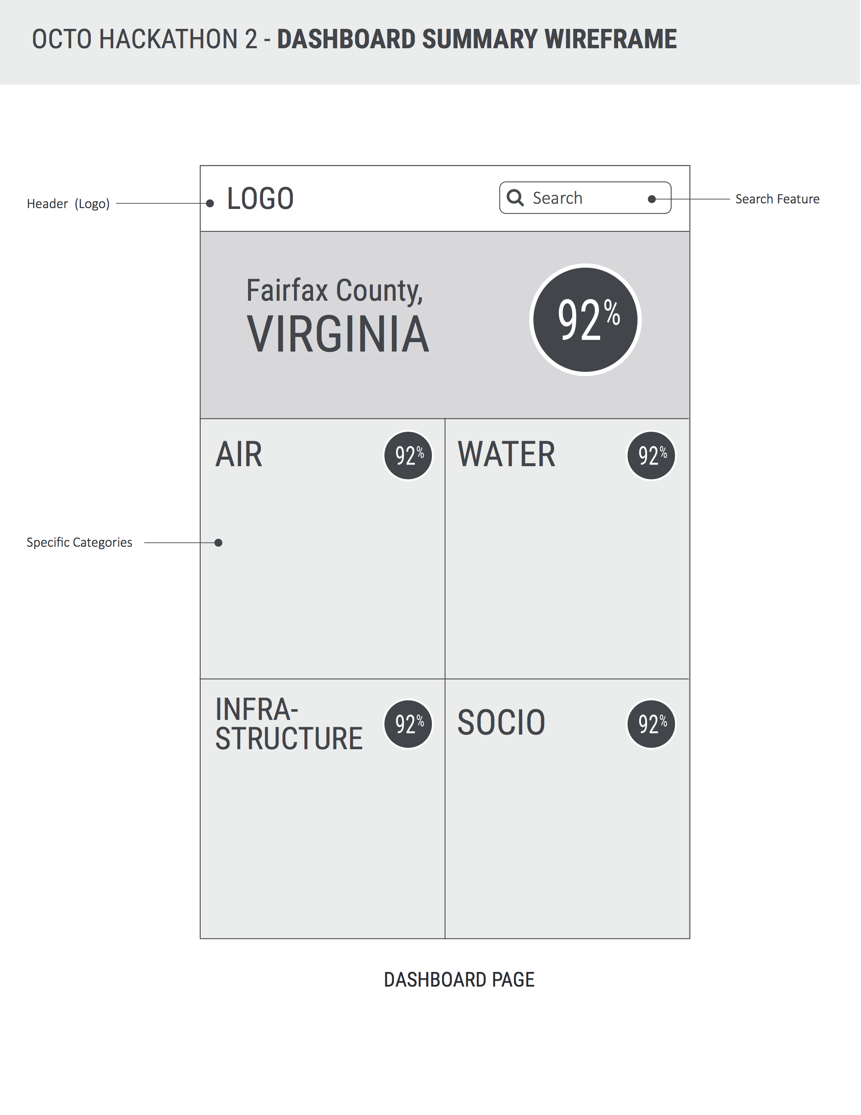**NGA Ebola Map**

1. The label “NGA Ebola Map” is inaccurate. The map is of the operational status of Ebola Support Centers. Labeling needs to reflect this.
2. The legend does could provide to users via hover help greater detail about the differenct categories: Operational, under construction, site surveyed, and TBD.
3. The symbols used on the map need to contrast the map background sufficiently so as to be identifiable. In this case, the “white cross” symbol used to indicated surveyed sites is hard to see against the “off white” map background.

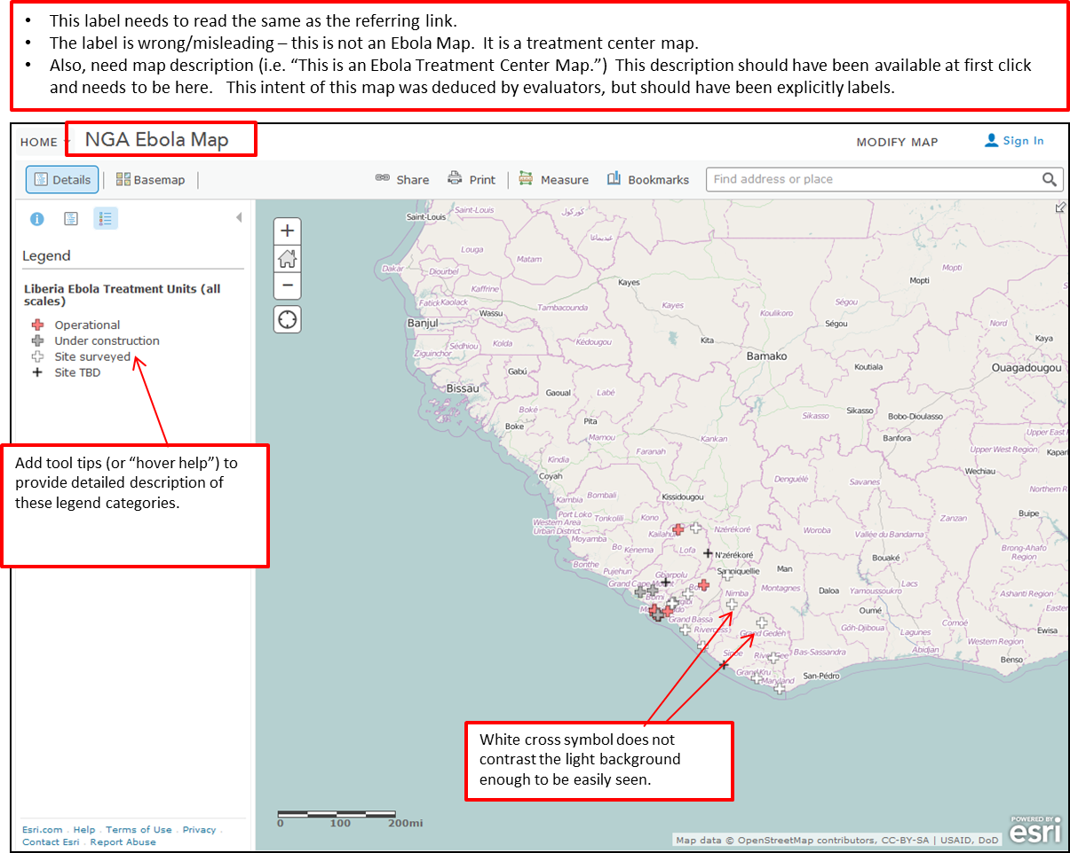

**Navigation**

1. Home Button. The home button should not be a drop-down menu.
2. Help Button. In this UI, “help” button is hidden in the home drop down.
   1. By convention, “help” should always be visible and is typically found in the upper right hand corner of the UI.
   2. In this particular case, “help” causes the UI to navigate to an ESRI help page and does not provide any insights to the users about the map data.
   3. Help should be available to users for both the ESRI tool and for the map data. Labeling for the help should be sufficient for users to be able to identify the difference.

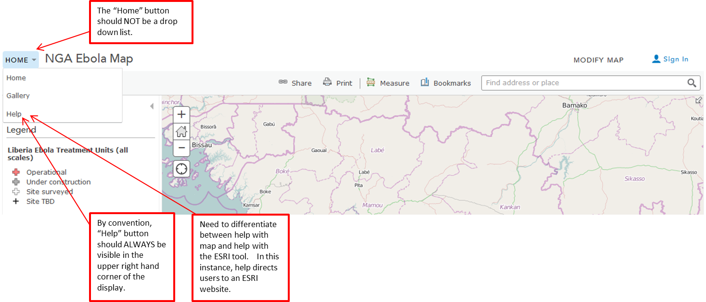

**Stability**

1. For users to be able to trust a tool, it needs to be available at the time they need it. During the heuristic evaluation of the “Ebola Map” – the browser froze repeatedly. This was true for Firefox, Google, and Explorer running on SBU thin client.

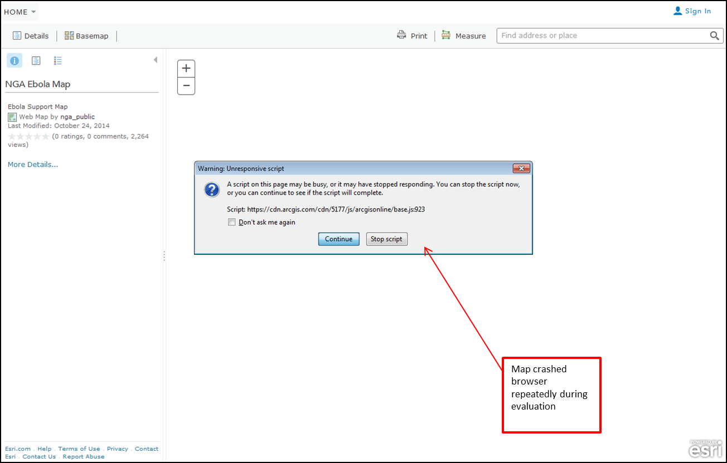

**Conclusion**

Although information for Ebola Support Centers is available from the NGA home page, it could benefit from clearer labeling and indicators to users regarding the freshness and currency of the data.

From the Ebola Support page, users should have more detailed description of what maps are available and the last time they have been updated. Users should be better informed of the similarity and differences of available maps and tools.

Finally – help functionality should distinguish between tool help and data help. Help for ESRI tools should be dynamic, rather than simply referring to the ESRI site. Tools for map data should help users identify the recency of data.